Guide

CREATING A RETURN TO WORK PLAN.

Table of Contents
Introduction 3
Reopening Decisions and Risk Assessments 4
Conducting a Risk Assessment 4
Creating a Pandemic Response Team 6
Preparing for Reopening 8
Modifying the Workplace 8
Disinfecting the Workplace 9
Establishing Employee Screening, Exposure and Confirmed Illness Protocol 10
Employee Screening Protocols 10
Exposure and Confirmed Illness Protocol 10
Creating Employee Safety Training Materials 11
Social Distancing Guidelines 11
Use of PPE 12
Personal Hygiene and Etiquette 12
Cleaning Responsibilities 12
Industry- and Business-specific Safety Considerations 13
Reviewing Workplace Policies 13
Reopening Your Business 14
Conclusion 15

This guide is intended for informational purposes only and does not include provincial or local guidance related to COVID-19. In addition, it should not be used as legal or medical advice. Please consult a legal or medical professional for further advice. © 2020 Zywave, Inc. All rights reserved.

Introduction
The COVID-19 pandemic has interrupted many businesses across the country. While it’s unclear how long COVID-19 will continue to affect organizations, many employers are looking to the future of employees returning to work.
Echoing the sentiments of public health officials, a return to normalcy won’t be like flipping a switch, but rather a gradual effort. In preparation for reopening your business and asking employees to come back to work, it’s imperative that your company thoughtfully constructs a return to work action plan for its employees to keep everyone healthy and safe following the COVID-19 pandemic.
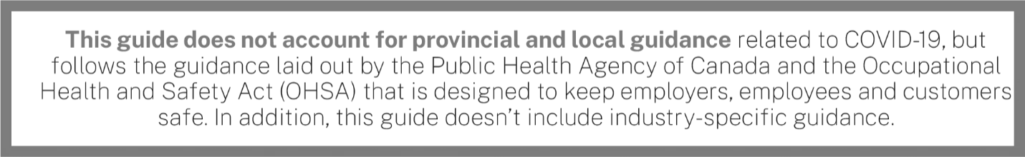



Reopening Decisions and Risk Assessments
While many essential businesses (e.g., hospitals, pharmacies, grocery stores and gas stations) have remained open during the COVID-19 pandemic, other operations deemed non-essential have shut down temporarily or changed the nature of their operations. Not only has this led to significant business disruptions, but, for many, it has critically impacted their bottom line.
However, we may be nearing a time when stay-at-home regulations are scaled back and all businesses are allowed to resume as normal. The question then is: How will business owners know it is acceptable to reopen? The following are some best practices to keep in mind:
- Review guidance from provincial and local governments—The COVID-19 pandemic impacts provinces and regions in different ways. Just because a business is allowed to reopen in one region of the country doesn’t automatically mean your operations will be allowed to resume as well. As such, it’s critical to understand and review all relevant provincial and local orders to determine if and when your business is allowed to reopen.
- Understand the risks—If and when the government allows all businesses to reopen, that doesn’t necessarily mean COVID-19 is no longer a threat to your operations. What’s more, some businesses may have greater COVID-19 exposures than others, underscoring the importance of performing a thorough risk assessment before reopening. Prior to conducting a risk assessment, it’s important to review guidance from OHSA, provincial and local agencies, industry associations and your local health department. More information on conducting a risk assessment can be found below.
Again, before reopening, it’s critical to seek the expertise of legal, insurance and other professionals.

Conducting a Risk Assessment
Even after the government allows businesses to reopen, firms still need to determine whether it makes sense to resume operations. Safely restarting your business won’t be as simple as unlocking the front door.
Before reopening, businesses should perform a risk assessment to determine what steps must be taken. While the complexity of risk assessments will differ from business to business, they typically involve the following steps:
- Identifying the hazards—When it comes to COVID-19, businesses need to think critically about their exposures, particularly if an infected person entered their facilities. When identifying hazards, it’s a good idea to perform a walk-through of the premises and consider high-risk areas (e.g., breakrooms and other areas where people may congregate). It’s also important to consider what tasks employees are performing and whether or not they are especially exposed to COVID-19 risks when performing their duties.
- Deciding who may be harmed and how—Once you’ve identified hazards to your business, you need to determine what populations of your workforce are exposed to COVID-19 risks. When performing this evaluation, you will need to make note of high-risk individuals (e.g., staff members who meet with customers or individuals with pre-existing medical conditions).
- Assessing risks—Once you have identified the risks facing your business, you must analyze them to determine their potential consequences. For each risk facing your business, you’ll want to determine:
  - How likely is this particular risk to occur?
  - What are the ramifications should this risk occur?
When analyzing your risks, consider potential financial losses, compliance requirements, employee safety, business disruptions, reputational harm and other consequences.
- Controlling risks—With a sense of what the threats to your business are, you can then consider ways to address them. There are a variety of methods businesses can use to manage their risks, including:
- Risk avoidance—Risk avoidance is when a business eliminates certain hazards, activities and exposures from their operations altogether.
- Risk control—Risk control involves preventive action.
- Risk transfer—Risk transfer is when a business transfers their exposures to a third party.
For COVID-19, control measures could include cleaning protocols, work-from-home orders and mandated personal protective equipment (PPE) usage.
- Monitoring the results—Risk management is an evolving, continuous process. Once you’ve implemented a risk management solution, you’ll want to monitor its effectiveness and reassess. Remember, COVID-19 risks facing your business can change over time.
If—after completing a risk assessment and reviewing provincial and local guidance—your organization determines it’s safe to reopen, it’s time to create your return to work action plan.

Creating a Pandemic Response Team
To ensure that employees receive clear communications and that your company is on the same page when it comes to your return to work action plan, it’s essential that you create a pandemic response team. A pandemic response team is a cross-functional team that recommends and oversees workplace protocols to control the spread of COVID-19. The scope and design of your team will vary depending on your specific business, but it should at least include the following roles:
- Team lead(s)—[Insert name of individual or department] is responsible for the overall action plan. [Insert name of individual or department] is responsible for working with company stakeholders and relevant health and safety bodies to manage this action plan.
- COVID-19 prevention and protocols lead—[Insert name of individual or department] is responsible for recommending and developing protocols to ensure the well-being of all employees. They are also tasked with overseeing procedures for isolating employees should they become sick at work.
- Sanitization and disinfection lead—[Insert name of individual or department] manages logistics related to daily and periodic sanitation and disinfection efforts. Their responsibilities include ensuring that routine cleanings are completed and that the necessary cleaning supplies are readily available.
- Communication lead—[Insert name of individual or department] is tasked with managing any and all pandemic-related communications. They will work with HR and internal communication stakeholders to ensure COVID-19 training is completed and that employees and their managers understand their role in preventing the spread of the disease. [Insert name of individual or department] will provide COVID-19 related updates on a [insert frequency] basis and as needed.
By breaking up your company’s response efforts, it will be easier for your organization to be thorough and ensure that no step is missed. After all, just one misstep can lead to the quick spread of COVID-19, jeopardizing the well-being of workers.
One of the first tasks your pandemic response team should address is outlining responsibilities for managers and supervisors, as well as employees. When it comes to ensuring a safe workplace during the COVID-19 outbreak, both managers and employees have their role to play.
- Managers and supervisors—Leadership, including managers and supervisors, should familiarize themselves with the details of the action plan. Above all, leadership must be prepared to answer questions from employees and set a good example by adhering to the guidance prescribed in the plan. This involves practising social distancing and good personal hygiene.
- Employees—Employees play a critical role in ’s COVID-19 prevention efforts. To protect everyone in the organization, outline a number of best practices that employees should follow:
  - Understand the signs and symptoms of COVID-19, and stay home if you are feeling sick—Any employee who is experiencing symptoms of COVID-19 (e.g., fever, cough, shortness of breath, sore throat, runny nose, body aches, chills or fatigue) should stay home. Individuals experiencing such symptoms should also be instructed to consult guidance from the Public Health Agency of Canada on seeking medical care.
  - Practise good hygiene—Employees should clean their hands often, either with an alcohol-based hand sanitizer or soap and water. Hand sanitizers should contain at least 60 per cent to 95 per cent alcohol, and employees should wash their hands with soap for at least 20 seconds. In addition, employees should avoid touching their face and cough into their arm.
  - Practise social distancing—Social distancing is the practice of deliberately increasing the physical space between people to avoid spreading illness.
In addition to ensuring that your company’s approach to reopening following the COVID-19 pandemic is a joint effort, establishing a pandemic response team will demonstrate to your employees that you’re committed to their safety and well-being.

Preparing for Reopening
Before you reopen your business, you’ll need to think about how you can do so safely. Most businesses will not be able to flip a switch and go from closed to open, but rather will need to reopen in phases. This section provides an overview of how to prepare for reopening.

Modifying the Workplace
To prevent the spread of COVID-19 after reopening your business’s doors, your company may need to make office modifications. These workplace modifications will most often be based on social distancing protocols, which may also be required by provincial or local orders as a condition of being permitted to reopen.
Your business’s social distancing plan will be unique to your industry and nature of work, but public health experts point to three key factors to consider when creating a social distancing plan and making necessary workplace changes:
- Physical workspace modifications—Because COVID-19 spreads through close contact, employers may need to make changes to employees’ desks or workstations, and overall floor plans. Some suggested changes include the following:
  - Separating desks and workstations to ensure that there are 2 metres between each station
  - Adding partitions to open floor plans
  - Closing common spaces, including conference rooms, breakrooms and cafeterias
  - Modifying high-touch surfaces (e.g., propping doors open) to keep employees from unnecessarily touching surfaces
  - Posting signage around the office to remind employees of social distancing protocols
  - Establishing contactless drop zones for all deliveries including mail, packages and food
  - Banning all workplace visitors and vendors
- Workplace protocols—To keep employees safe, your business will need to change protocols for in-person interactions and physical contact. Some suggested changes include the following:
  - Establishing and enforcing a crowd control plan to ensure that only a few employees are in the building at once
  - Prohibiting in-person meetings whenever possible and encouraging the use of virtual meetings instead
  - Limiting the size of in-person gatherings and meetings to less than 10 people
  - Encouraging employees to avoid sharing workstations or equipment
  - Staggering meal times and breaks to avoid having large groups of employees together at once
  - Banning all business travel until further notice
- Employee scheduling—To minimize the number of employees at work at any given time, changes to employee scheduling may need to be made and enforced. Some suggested changes include the following:
  - Permitting only essential employees in the office
  - Encouraging all other employees to work remotely, if possible
  - Staggering shifts
  - Creating groups of employees who are to work together in shifts throughout the pandemic response

Disinfecting the Workplace
Before you reopen the workplace, you should clean and disinfect it. Some professional cleaning services may be available to hire for a deep-clean and disinfection of your business. However, if you need to clean your office or building yourself before reopening, keep the following tips in mind.
- Wear proper PPE—Don’t risk exposure or contamination while cleaning. Be sure to wear PPE, including gloves and a mask, while you’re cleaning the workspace. Avoid touching your eyes, face or mouth, or any personal electronic devices, while you clean.
- Clean first, then disinfect—Disinfectant works best on already clean surfaces. As such, do a general cleaning before you start disinfecting the office or building. Go beyond the standard cleaning routine, and make sure to pay close attention to the following areas:
  - Entryways and exits
  - High-touch common surfaces (e.g., light switches and plate covers, doors, cabinets, sinks, stair railings, countertops, beverage machines, refrigerators and elevator buttons, if applicable)
  - Employee workstations
  - Electronics
  - Tables, chairs and desks, from the lobby to the conference room
- Disinfect all spaces with a Health Canada-approved disinfectant—Double-check that the disinfectant being used is listed on Health Canada's list of disinfectants for use against COVID-19. Disinfect all possible spaces, focusing on high-traffic and commonly touched surfaces.
- Replace your air filters—Increasing the ventilation and changing out old air filters can help promote workplace health. Talk to your building owner to learn more about the filters used in your HVAC systems.
Once your office or building is clean, work with the pandemic response team to establish a plan for daily cleaning of the space and promoting employee cleanliness. One of the best defences against the spread of COVID-19 is keeping your workplace clean and regularly disinfected.

Establishing Employee Screening, Exposure and Confirmed Illness Protocol
Keeping employees safe should be a priority, and given the contagious nature of COVID-19, it may be in your company’s best interest to implement formalized screening and exposure protocols.

Employee Screening Protocols
To keep employees safe, consider conducting screening procedures to identify potentially ill employees before they enter the office. It is generally impermissible for employers to measure employees’ body temperatures before allowing them to enter the work site, unless an occupational requirement can be established. Therefore, non-invasive thermal testing for COVID-19 may be permissible dependi98ng on local and provincial regulations. Any employee screening should be implemented on a non-discriminatory basis, and all information gleaned should be treated as confidential medical information—specifically, the identity of workers exhibiting a fever or other COVID-19 symptoms should only be shared with members of company management with a true need to know. Be sure to notify employees that you will be screening them to avoid any surprises.

Exposure and Confirmed Illness Protocol
Employees who test positive for COVID-19 or believe they have been infected will be instructed to follow the advice of a qualified medical professional and self-quarantine. When self-quarantining, employees should:
- Stay away from other people in their home as much as possible, staying in a separate room and using a separate bathroom if available.
- Not allow visitors.
- Wear a face mask if they have to be around people.
- Avoid sharing household items, including drinking cups, eating utensils, towels and bedding.
- Clean high-touch surfaces daily.
- Continue monitoring their symptoms, calling their health care provider if their condition worsens.
Notably, employees who are symptomatic or who have tested positive should not return to work until the conditions outlined in the table on the next page are met:

Return to Work Considerations
Employee was symptomatic but was  not tested for COVID-19. | Employee was tested for COVID-19.
The employee may return to work if:  They have not had a fever for at least 72 hours and have not used fever-reducing medication during that time.  Coughs and other symptoms have improved.  Ten days have passed since they first experienced symptoms. | The employee may return to work if:  They no longer have a fever.  Coughs and other symptoms have improved.  They have received two negative COVID-19 tests in a row.

When an employee tests positive for COVID-19, deep-cleaning procedures will be triggered. Furthermore, employees who have been in close contact with an individual who has tested positive for COVID-19 will be instructed to self-quarantine.

Creating Employee Safety Training Materials
The success of your return to work action plan, no matter how well-thought-out and comprehensive it may be, is largely contingent upon how well your employees follow your health and safety guidance. Your employee safety training materials should cover the following topics.

Social Distancing Guidelines
Ask employees to follow social distancing best practices throughout your facilities, including but not limited to cafeterias, common areas and office spaces. Specifically, encourage employees to:
- Stay 2 metres away from others when working or on breaks. Where a minimum distance cannot be maintained, engineering or administrative controls will be in place.
- Avoid job tasks that require face-to-face work with others when possible. If this is unavoidable, employees will be provided with face masks, face shields, physical barriers and other workplace controls to ensure their safety.
- Avoid contact with others whenever possible (e.g., handshakes).
- Avoid touching surfaces that may have been touched by others when possible.
- Distance themselves from anyone who appears to be sick.
- Avoid gathering when entering and exiting the facility. Employees should also only enter and exit designated areas.
- Follow any posted signage regarding COVID-19 social distancing practices.
- Disinfect their workspace often.
- Avoid touching their face.
- Avoid non-essential gatherings.

Use of PPE
If you’ve determined that your employees should use PPE while at work, be sure to explain best practices for its use. For example:
- Gloves—Employees may contract COVID-19 by touching contaminated surfaces and then touching their face. Gloves are an effective way to prevent COVID-19 from getting on an employee’s skin. They are also a good reminder for employees not to touch their face.
- Face shields, face masks and eye protection—Viruses can be transmitted through the eyes and mouth via tiny viral particles known as aerosols. Face shields, face masks and eye protection can help protect employees from these particles.
At a minimum, your return to work action plan should include guidance for employees to understand how to put on, take off and care for any PPE provided to them.

Personal Hygiene and Etiquette
Your employee safety training materials should include guidance for employees as it pertains to personal hygiene and etiquette to prevent the spread of COVID-19. Specifically, you should include guidance for the following:
- Respiratory etiquette and hand hygiene—Encourage good hygiene to prevent the spread of COVD-19. This can involve:
  - Providing tissues and no-touch disposal receptacles
  - Providing soap and water in the workplace
  - Placing hand sanitizers in multiple locations to encourage hand hygiene
  - Reminding employees to not touch their eyes, nose or mouth
- Staying home when sick—Encourage employees to err on the side of caution if they’re not feeling well and stay home when they’re sick or are exhibiting common symptoms of COVID-19 (e.g., fever, cough or shortness of breath).

Cleaning Responsibilities
Because COVID-19 can remain on surfaces long after they’ve been touched, it’s important that your business frequently cleans and disinfects the facility. Employees should be responsible for ensuring that they do their part in maintaining workplace cleanliness. Some best practices to promote cleanliness include:
- Discouraging workers from using other workers’ phones, desks, offices, or other tools and equipment, when possible. If necessary, clean and disinfect them before and after use.
- Providing disposable wipes so that commonly used surfaces can be wiped down by employees before each use.

Industry- and Business-specific Safety Considerations
Be sure to also include any industry- or business-specific safety training materials in your return to work action plan. Please refer to OHSA for more detailed information regarding this guidance.

Reviewing Workplace Policies
The COVID-19 pandemic has resulted in employers across the country needing to change their workplace policies to adhere to new legislation and to better represent their newfound situation. As such, your company should review its workplace policies to ensure that they’re in line with your return to work action plan and in compliance with any applicable laws.

Reopening Your Business
When your business is ready to reopen, you should do so in a manner that balances your needs and the health and safety of employees. As such, consider reopening in phases, and be sure to provide ample employee communications throughout the entire process. Depending on your business and location, this phased-in approach to reopening will vary.
You will need to keep provincial and local guidance related to social distancing in mind when reopening your business. For example, if your local guidance prohibits gatherings of more than 10 people, it may not be advised or permitted for all employees to return to work. Consider asking only essential employees to return to work. As regulations begin to permit allowing larger gatherings, incrementally increase the number of employees permitted within the office or building. Whenever possible, leverage telecommuting and rotating schedules to keep employees safe.
Be sure to implement any screening or workplace protocols that were created prior to reopening your business. In addition, make sure to provide any necessary managerial or employee training to ensure that every employee understands how they can do their part in preventing the spread of COVID-19 once your business reopens. Consider distributing an employee version of your return to work action plan to be as transparent as possible. The COVID-19 pandemic has created stress and uncertainty for many employees, and the prospect of returning to work in the midst of the pandemic can cause uneasiness among employees. By being transparent, employees will know what to expect and will be able to see the steps you’re taking to protect them while they’re at work.
In addition, it’s important to remain flexible and adaptive throughout your reopening process. Due to the nature of the COVID-19 pandemic, rules and regulations are constantly changing. You should be prepared to change your business practices if needed to maintain critical operations. Depending on how the pandemic progresses, you may need to make changes to your return to work action plan, suspend operations again or add additional safety measures.

Conclusion
While resuming operations following the COVID-19 pandemic may seem like a daunting task, businesses don’t have to go it alone. To help with this process, organizations can seek the help of their insurance professionals to determine what actions they need to take to ensure their business reopens smoothly. To learn more, contact Lloyd Sadd Insurance Brokers Ltd today.
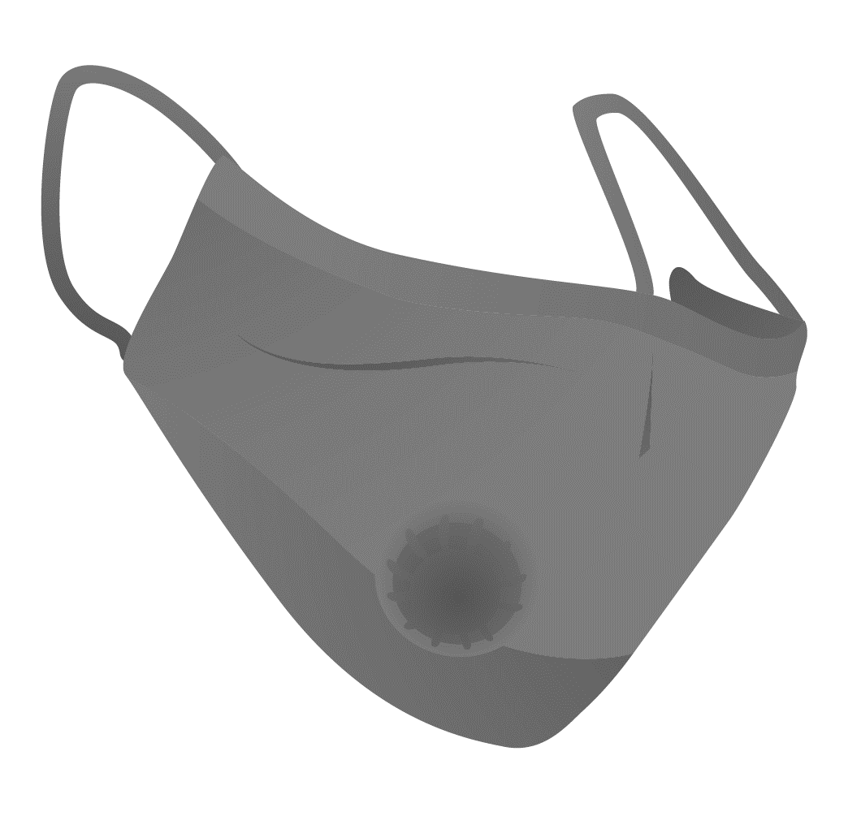
Furthermore, while the strategies highlighted in this document can protect workers from COVID-19, it’s important to follow Public Health Agency of Canada guidance at all times. For more information, click here.

